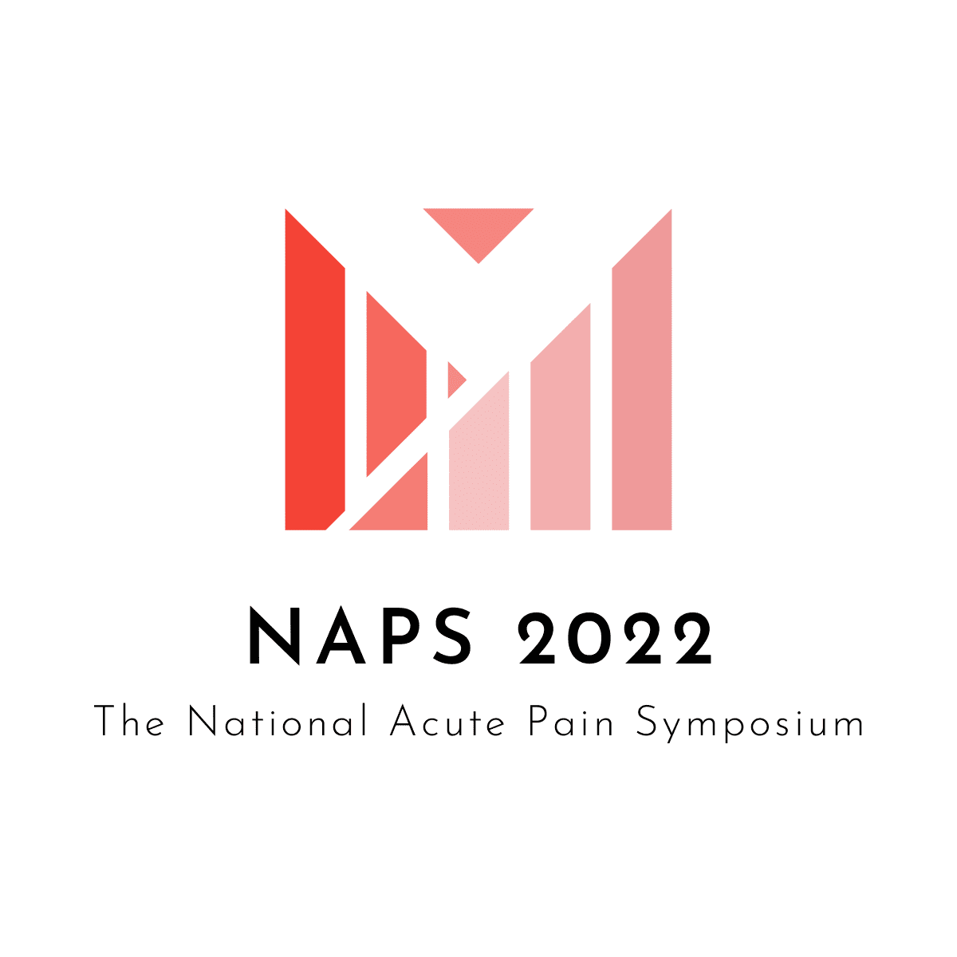
Warwick Conferences – The Slate- 20/21 October 2022 | Exhibitors Information
Welcome to the National Acute Pain Symposium 2022, which is returning to Warwick Conferences on Thursday and Friday 20-21 October 2022 – slightly later in the annual calendar to accommodate the IASP event in Toronto in September – with another great education programme in Acute Pain and Pain Management.
With the easing of restrictions, we are now contracted at the venue to double our live audience from 2021 and we are hoping to get our numbers back to a pre-pandemic level of 250 + delegates.
Virtual, live and all-inclusive options are once again available for all delegates and we will be repeating our ‘passport’ programme to encourage engagement throughout the event with our Trade supporters, who remain an important part of NAPS.
Our trade exhibition offers options including our awards dinner on the Thursday evening which has proved a popular element of the programme.
We have two basic packages, and you are welcome to add additional personnel, increase your stand size, attend the awards dinner, and secure accommodation on site, all to suit your objectives and budget:
Option One Thursday 20 & Friday 21 October 2022 £795.00+vat
- 6ft Trestle Table
- Two Company Representatives
- Lunch & Refreshments through the Event
- Branding on Welcome & Screens
- Website Profile
- Access to the Delegate List
- Social Media & Marketing Coverage
- Virtual Video Option

Option Two Thursday 20 & Friday 21 October 2022 £975.00+vat
- 6ft Trestle Table
- Two Company Representatives
- Lunch & Refreshments through the Event
- Branding on Welcome & Screens
- Website Profile
- Access to the Delegate List
- Social Media & Marketing Coverage
- Two Tickets to the NAPS Social Evening & Awards
- Virtual Video Option
Optional Extras
- Additional 6ft Trestle Table £395.00+vat
- Additional Company Representative Per Day £75.00+vat
- Additional NAPS Social Evening & Awards Dinner Per Person £99.00+vat
- On Site Accommodation incl. Breakfast per night Per Person £97.50+vat

We also welcome ideas from our Trade Supporters to enhance the event and the education of our delegates. To discuss the options or for additional information please contact
Paula Kelsey
Cloud 9 Event Management for the National Acute Pain Symposium
E. paula@cloud9em.co.uk
T. +44(0)203 858 7809
M. +44(0)7774 741883

Please note our cancellation policy and compliance statement and use the booking form to confirm your participation.

Event Cancellation Policy

If you should have to cancel your stand, notification in writing should be sent to
naps@cloud9em.co.uk
​
- A refund of 85% will be given for cancellations received 90 days prior to the start of the event
- A refund of 50% will be given for cancellations received between 89 days prior to 61 days to the start of the event
- A refund of 25% will be given for cancellations received between 60 days prior to 31 days to the start of the event
- No refund will be issued for cancellations received within 30 days of the event, nor failure to attend

Force Majeure Cloud 9 Event Management Ltd, who operate the National Acute Pain Symposium, shall not be liable to refund of fees or for any other penalty should the event be cancelled due to war, fire, strike lock-out, industrial action, tempest, accident, civil disturbance, or any other cause whatsoever beyond their control.
​
Compliance
The National Acute Pain Symposium takes compliance regulations seriously and understands that our event is for the continued education of the healthcare sector, and not about the enjoyment of those in attendance. Although hospitality must be restricted to the main purpose of the event only, with any additional offerings being classed as second to the event, we do consider the Awards and the recognition and professional development of our healthcare audience a key element within the symposium.
We regularly review our subsistence policy to ensure it is compliant and we are able to include refreshments (meals and drinks), accommodation, genuine registration fees and reasonable travel costs which we provide only for our speakers. We do not offer incentives for mere attendance.
Our venue has been selected on the basis that the event will be private and not accessible to the public. Staging a meeting sponsored by pharmaceutical companies is frequent and clear signposting of it remains important. All papers and materials distributed in session must contain messaging that informs visitors of the organisation behind it all. Pharmaceutical companies must publicly declare any financial details concerning sponsorship of UK health professionals and associated staff were they to frequent a conference. This must materialise in the calendar year following that in which payments were made. The information must be public within three months of that company’s financial year drawing to a close. Monetary contributions could range from registration fees right through to travel expenses. Either way, transparency is essential.
As for the type of event those aforementioned pharmaceutical companies can prop-up they include Lunchtime audio-visual presentations in a group practice | Hospital meetings and meetings at postgraduate education centres | Advisory board meetings | Visits to research and manufacturing facilities | Planning, training and investigator meetings for clinical trials and non-interventional studies | Launch meetings for new products | Management training courses | Patient support group meetings | Satellite symposia | International meetings organised by independent bodies with sponsorship from pharmaceutical companies
In the name of originality, the ABPI allow for varied subject matter however all conferences must have what they term ‘clear educational content.’ The latter guards against any form of social gathering unfolding under the false pretence of a medical banner. When it comes to entry itself no husbands or wives of the medical professional are welcome while administrative staff are only granted access if the course material is specific to them.
PLEASE NOTE OUR NEW ADDRESS
The National Acute Pain Symposium c/o Cloud 9 Event Management Ltd | 14 Vancouver Avenue | Radcliffe on Trent | Nottingham | NG12 2ES | United Kingdom | T. +44 (0) 203 858 7809 | Est. 2003 Company Registered in England & Wales No.4734630 | VAT No 815 7554

Exhibitor Booking Form
Office Use Only:
Company Name
Lead Contact Name
Email
Mobile No.
Booking Options |  |  | Total £
Option One |  | £795.00
Option Two |  | £975.00
Additional Table @ £395.00 |  | £395.00 x
Additional Personnel @ £75.00 Per Day |  | £75.00 x
Additional NAPS Social Evening Per Person £97.50 |  | £97.50 x
Accommodation
Accommodation 19 Oct & Breakfast 20 Oct £97.50pp |  | £97.50 x
Guest Name(s)

Accommodation 20 Oct & Breakfast 21 Oct £97.50pp |  | £97.50 x
Guest Name(s)

Sub Total
VAT @ 20%
Total Payable

We confirm our booking for NAPS 22 and understand that prepayment is required. Please invoice us at (insert address):
PO/Ref No: | Date:
Name: | Title:

Please return this form to paula@cloud9em.co.uk

Asset Checklist

Your Asset Checklist for the National Acute Pain Symposium
Please send all items to paula@cloud9em.co.uk

250 Words of Copy (Approx.) for the Website

Contact Name for the Website Link

Any Social Media Links or Hashtags

Representatives Names & Any Dietary Requirements

We will have the opportunity to play video content during the refreshment breaks for our virtual delegates. You have the option to send a video or PPT converted to an MP3 of a maximum of 10 minutes in length. Please note that is optional and video content must be received no later than 1 September 2022 in order to be included.
Video Content

Thank You

